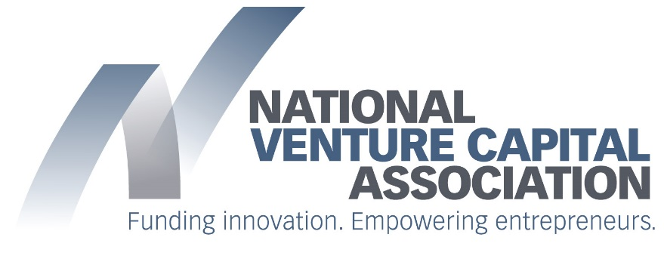

FOR IMMEDIATE RELEASE | Contact: Ben Veghte
June 8, 2016 | Phone: 202-864-5923

NVCA Cheers Passage of Bills by Homeland Security Committee to Open Procurement Process to Cybersecurity Startups

Federal Agencies Unable to Access Innovative Cybersecurity Solutions Due to Difficulties Startups Face Accessing Procurement Process

WASHINGTON, DC – The National Venture Capital Association (NVCA) issued the following statement today after the House Committee on Homeland Security passed the Support for Rapid Innovation Act of 2016 and the Leveraging Emerging Technologies Act of 2016, both introduced by Congressman John Ratcliffe (R-TX), Chairman of the House Homeland Security Subcommittee on Cybersecurity, Infrastructure Protection, and Security Technologies.

“Since 2010, venture investors have deployed $9 billion in venture capital funding to 351 high-growth cybersecurity startups. Working alongside venture investors as strategic advisors to scale and grow the businesses, these startups have developed some of the most innovative cybersecurity solutions on the market,” said Bobby Franklin, President and CEO of NVCA. “We are witnessing rapid adoption of these new products and services in the private sector, but unfortunately the federal government continues to miss out on these new innovations due to the difficulties startups face as they try to navigate the federal procurement process.”

“By their very nature, startups are fast and nimble, whereas the federal procurement process is slow and cumbersome,” added Franklin. “These bills would take much-needed strides to fixing the procurement challenges cybersecurity startups face, establishing a strategic plan for proactive engagement with cybersecurity startups and addressing structural barriers that hinder them from participating in the acquisition process. We thank Chairman Ratcliffe for taking the lead to address this important issue and look forward to engaging him and his colleagues on the Homeland Security Committee to develop reform measures that will allow for federal agencies to access innovative cybersecurity solutions developed by the startup community.”

Read NVCA’s letter of support to Chairman McCaul and Raking Member Thompson here.

###

Venture capitalists are committed to funding America’s most innovative entrepreneurs, working closely with them to transform breakthrough ideas into emerging growth companies that drive U.S. job creation and economic growth. As the voice of the U.S. venture capital community, the National Venture Capital Association (NVCA) empowers its members and the entrepreneurs they fund by advocating for policies that encourage innovation and reward long-term investment. As the venture community’s preeminent trade association, the NVCA serves as the definitive resource for venture capital data and unites its member firms through a full range of professional services. For more information about the NVCA, please visit www.nvca.org.

