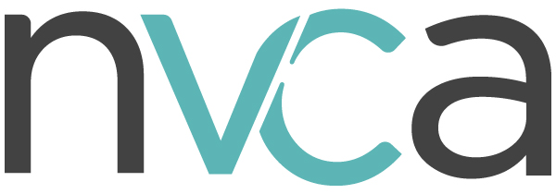

**Economic Support Tax Proposals for Startups During COVID-19 Economic Crisis**

**Challenge:** Across America, startups are pulling back on their operations to put their companies in a position to survive a liquidity crisis of unknown depth and duration. These companies are either in a loss position or completely pre-revenue while they build new products and technologies. Investors during economic crises pull capital away from this type of high-risk illiquid investment and towards safer and more liquid assets, putting startups and their 2.2 million employees at risk of exhausting the investment capital necessary to continue operations. Left unchecked, this pullback will cost hundreds of thousands of quality jobs and could cost us years of lost innovation. Further, startup activity supports many other service jobs, such as banking, retail, construction, sales, and human resources.

The startup ecosystem is a particularly difficult area of the economy to support, as it is a small and unique business model as companies take significant losses in early years in pursuit of innovation and growth.

To support the millions of workers who either directly work for these enterprises or support their operations, policymakers need to design economic relief to match the entrepreneurial business model.

**Solution:** Because startups are often either in a loss position or in the case of medical startups (e.g. biotechnology) completely pre-revenue, they accumulate significant amounts of tax assets, including net operating losses (NOLs) and R&D credits. Unfortunately, these assets have limited benefit in a liquidity crisis as the companies do not have taxable income to offset and tax regulations often severely limit their value. Policymakers should allow startups to immediately realize the value of these accumulated tax assets to the maximum extent possible. Doing so will improve cash flow (which impacts the ability to hire and retain workers) and valuations in one of the most vulnerable sectors of the economy.

**Proposals:** As the broader economic impact of our response to COVID-19 begins to be realized, there are several tax-specific proposals that would support the startup ecosystem during this crisis:

* *Make the R&D credit temporarily refundable:* Because of their research-intensive nature, many of these companies have significant amounts of accumulated R&D credits on their books. Many startups who are not yet profitable can currently offset up to $250,000 worth of payroll tax obligations a year with unused R&D credits. As a way to encourage and provide liquidity to innovative startups conducting research, Congress can temporarily make the credit refundable using a similar mechanism to the employer emergency leave credit. Congress can further improve the impact of the credit by adding companies who are qualified small businesses under Section 1202 to the universe of eligible businesses.
* *Create a temporary tax loss safe harbor for wage and research NOLs accrued over the next year*: Congress can support jobs and research activities at startups simply by allowing NOLs and R&D credits created through these expenditures to be exempt from Section 382/383 restrictions. These are assets on the balance sheet of VC-backed companies, but many get caught in the snare of tax regulations, making them largely worthless to the company. By allowing these assets to avoid the limitations of Section 382/383, Congress can encourage continued investment in jobs and research at startups, business activities that are amongst the most vulnerable during this crisis.